

Semester One Examination, 2019

Question/Answer booklet

Yr 12 SPECIALIST
UNIT 3

Section Two:

Calculator-assumed

Your Name

Your Teacher’s Name

Time allowed for this section
Reading time before commencing work: ten minutes
Working time: one hundred minutes

Materials required/recommended for this section
To be provided by the supervisor
This Question/Answer booklet
Formula sheet (retained from Section One)

To be provided by the candidate
Standard items: pens (blue/black preferred), pencils (including coloured), sharpener, correction fluid/tape, eraser, ruler, highlighters

Special items: drawing instruments, templates, notes on two unfolded sheets of A4 paper, and up to three calculators approved for use in this examination

Important note to candidates
No other items may be taken into the examination room. It is your responsibility to ensure that you do not have any unauthorised material. If you have any unauthorised material with you, hand it to the supervisor before reading any further.
Question | Marks | Max | Question | Marks | Max
8 |  | 6 | 15 |  | 8
9 |  | 6 | 16 |  | 4
10 |  | 8 | 17 |  | 4
11 |  | 5 | 18 |  | 9
12 |  | 5 | 19 |  | 13
13 |  | 6 | 20 |  | 9
14 |  | 10

Structure of this paper

Section | Number of questions available | Number of questions to be answered | Working time (minutes) | Marks available | Percentage of examination
Section One:  Calculator-free | 7 | 7 | 50 | 49 | 34.5
Section Two:  Calculator-assumed | 13 | 13 | 100 | 93 | 65.5
 |  |  |  | Total | 100

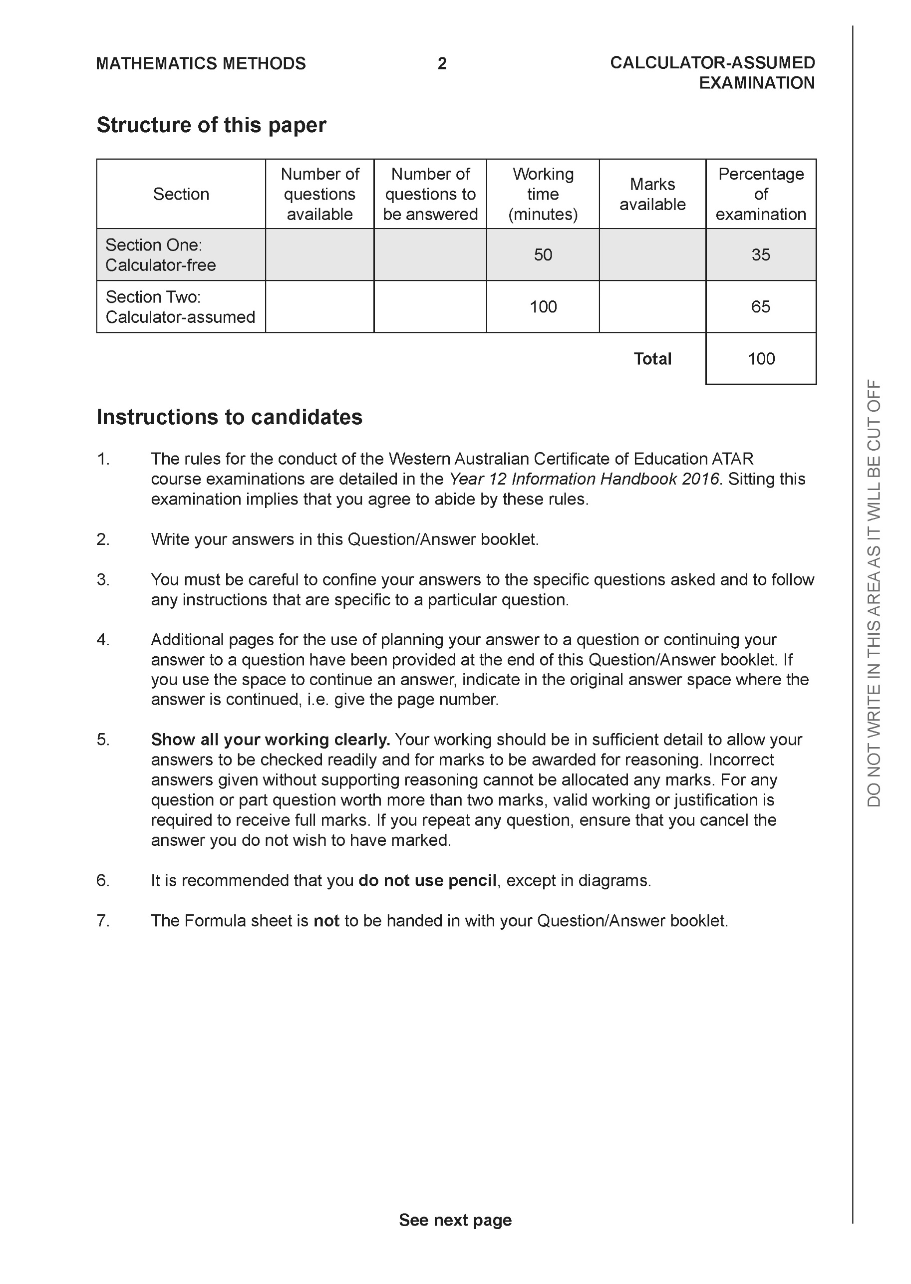

Section Two: Calculator-assumed (93 Marks)

This section has 13 questions. Answer all questions. Write your answers in the spaces provided.

Spare pages are included at the end of this booklet. They can be used for planning your responses and/or as additional space if required to continue an answer.
● Planning: If you use the spare pages for planning, indicate this clearly at the top of the page.
● Continuing an answer: If you need to use the space to continue an answer, indicate in the original answer space where the answer is continued, i.e. give the page number. Fill in the number of the question that you are continuing to answer at the top of the page.

Working time: 100 minutes.

Question 8 (6 marks)

- Sketch the following region in the complex plane, (3 marks)

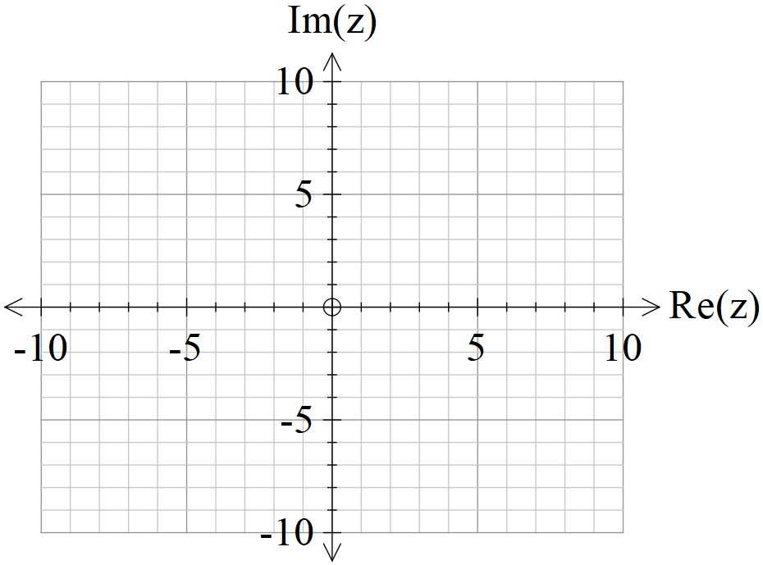

- Determine the cartesian equation of (3 marks)

Question 9 (6 marks)

- Given that , where is a constant, is only true for , determine the value of .
(3 marks)

- Given that , where are constants, is only true for , determine the values of . (3 marks)

Question 10 (8 marks)

Consider the locus of points on in the complex plane.
- Sketch this locus below. (2 marks)

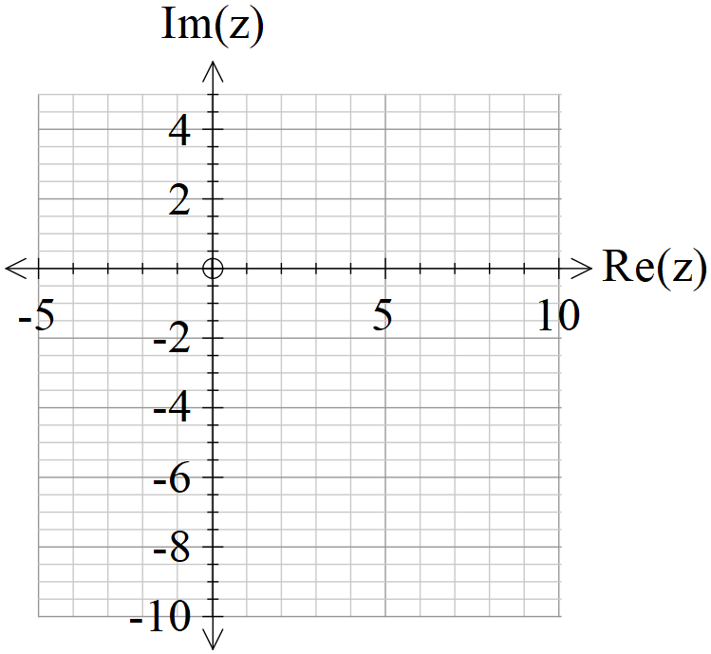

- Determine the minimum principal on this locus to one decimal place.
(3 marks)

- Determine the maximum value of on this locus. (3 marks)

Question 11 (5 marks)

Show that the line is parallel to the plane and determine its distance from the plane.

Question 12 (5 marks)

Let , where , consider the sum .
- Sketch a diagram of this sum in the complex plane. (2 marks)

- Obtain an expression for the in terms of . (3 marks)

Question 13 (6 marks)

- Determine a vector that is perpendicular to both and and has a magnitude of .(Do not simplify) (3 marks)

- Let and where is a real constant. In terms of , determine an expression for the angle between . (3 marks)

Question 14 (10 marks)
Consider a plane defined by .
- Determine a normal vector to this plane. (1 mark)

- Determine the cartesian equation of this plane. (2 marks)

- Show how to determine the distance of point from the plane above using scalar dot product and the normal vector. (4 marks)

- Consider a general plane , where are constants. Show that the distance of point from this plane is given by the expression (3 marks)

Question 15 (8 marks)

In deep space an astronaut is space walking outside a stationary space station. At time seconds the astronaut is positioned at metres relative to the space station and is moving with a velocity of metres per second. A rogue satellite is observed to be at position at time with a velocity of metres per second relative to the space station.

The satellite emits radiation and if the astronaut comes within 70 metres of the satellite the dosage will be harmful.

- Determine the distance between the astronaut and satellite at seconds.
(3 marks)

- Determine if the astronaut is in danger and if so for how long in seconds to two decimal places. (Justify your answer).
(5 marks)
Question 16 (4 marks)

Consider the two spheres and .
Determine whether there are any common points on both spheres. Justify your answer.

Question 17 (4 marks)

Show using vector cross product, how to determine the distance of point from the line .
Question 18 (9 marks)

Consider the line and the sphere where is a constant.
Determine the values of , to two decimal places, for each of the following scenarios:
(Justify your answers)
- the line does not meet the sphere at all.
- the line meets the sphere at two points.
- the line is a tangent to the sphere.
Question 19 (13 marks)

Consider a prism where opposite sides are congruent parallelograms(parallelepiped) with coordinates .

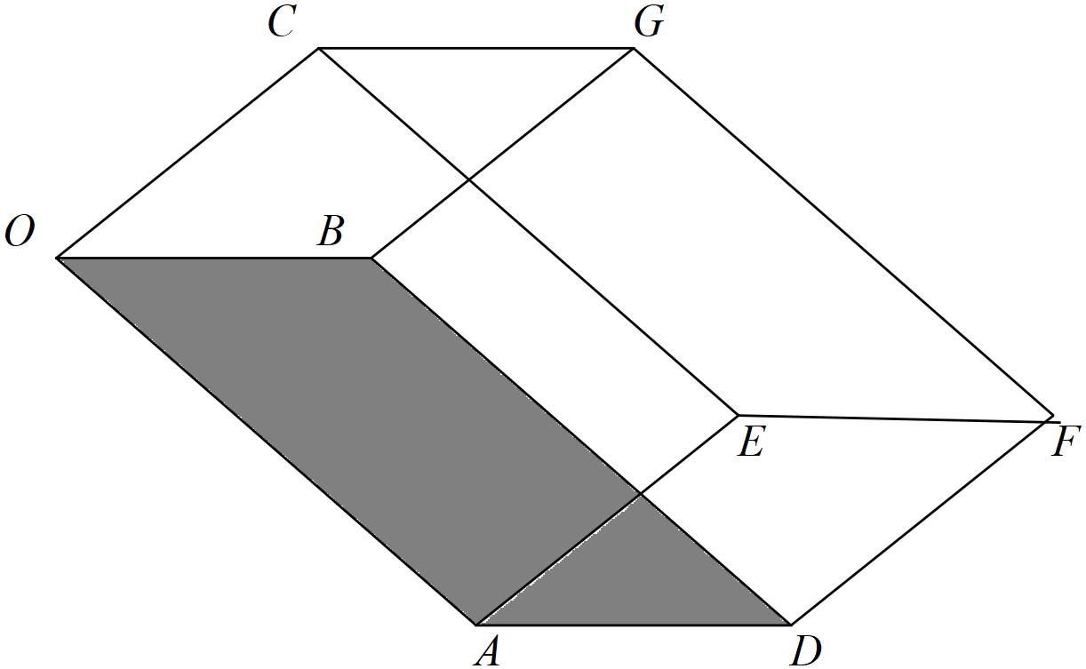

- Determine a unit normal vector to the base . (3 marks)

- Using this unit normal, determine the distance between the faces .
(Hint-use vector ) (3 marks)

- Show using cross product how to determine the area of the base .
(2 marks)

- Hence or otherwise, determine the volume of the prism. (3 marks)

- In terms of the vectors write an expression using cross and dot products to represent the volume of the prism. (2 marks)

Question 20 (9 marks)

Consider a single photon of light that is released from a box positioned at point A and moves in a direction of hitting a planar sheet of glass at point B. The planar sheet of glass is given by . The photon is refracted, that is changes direction, through the glass such that the angle with the perpendicular is and passes through point D.
It is given that the vectors and the normal are all in the same plane.

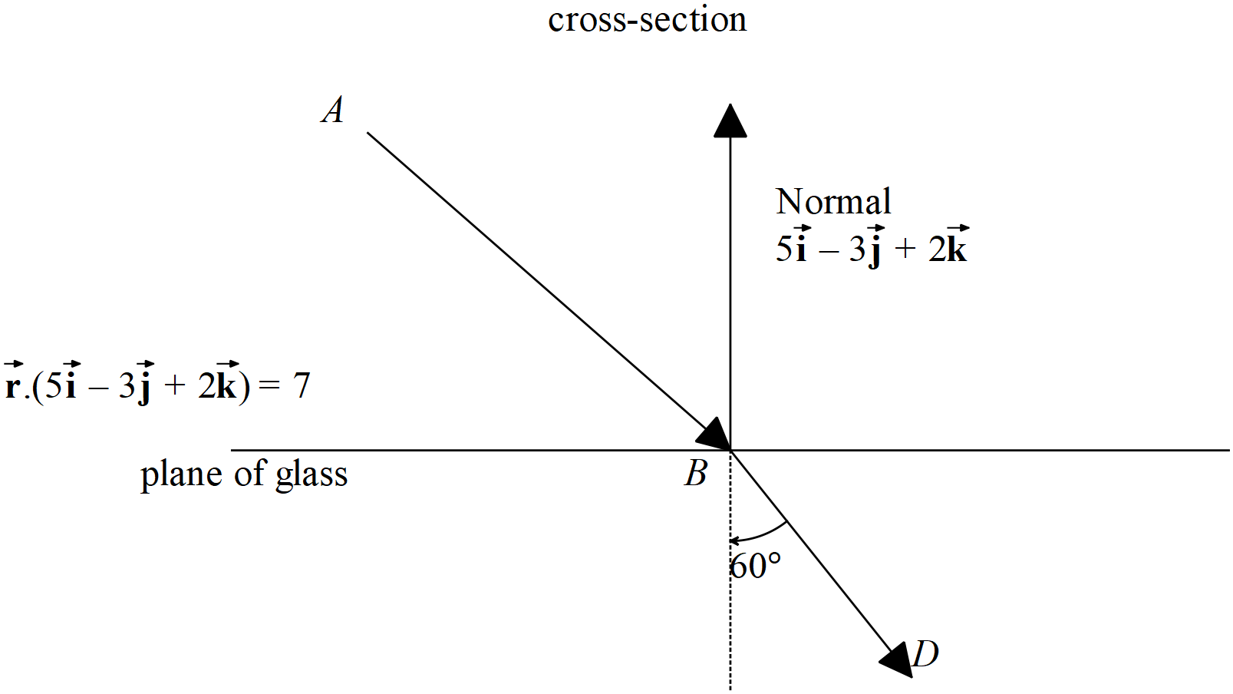
- Determine the point . (3 marks)

Assume that is a unit vector and be represented as with
- Determine two other independent equations for . (4 marks)
Question continued

- Hence solve for vector using your CAS calculator (simultaneous) to 2 decimal places.
(2 marks)

Additional working space
Question number:

Additional working space
Question number:

